## **Sales Commissions Analysis Project (Excel)**

### **Project Overview**

In this project, I built a dynamic Excel model to automate commission calculations, analyze branch performance, and enhance reporting accuracy using advanced Excel functions. The goal was to transform raw sales data into meaningful financial insights through structured formulas, named ranges, and automated summaries.

## **Key Skills Demonstrated**

### **1. Data Structuring with Named Ranges**

I improved formula reliability and readability by converting lookup tables into named ranges. This allowed formulas to remain dynamic and easier to maintain as data changes.

**Skills shown:**

* Data organization
* Best practices for scalable spreadsheet models

### **2. Advanced Lookup Automation (XLOOKUP)**

I implemented **XLOOKUP** to automatically assign bonus rates based on commission levels. This eliminated manual lookups and ensured accurate tier-based compensation.

**What I built:**

* Dynamic lookup system using named ranges
* Approximate match logic to handle tiered commission structures

**Business value:**Prevents human error and allows instant recalculation when commission levels change.

### **3. Financial Modeling with Order of Operations**

I designed formulas that calculate total earnings by correctly applying mathematical precedence using parentheses.

**What I built:**

* Automated calculation of total pay = base commission + bonus-adjusted commission

**Skills shown:**

* Financial logic modeling
* Precision in multi-step calculations

### **4. Performance Reporting with Conditional Aggregation (SUMIF)**

I used **SUMIF** to calculate total earnings by branch office, creating an automated summary that updates as data changes.

**What I built:**

* Branch-level revenue summaries
* Executive-style reporting section

**Business value:**Allows management to instantly compare branch performance without manual filtering.

### **5. Descriptive Statistics for Business Insights**

To analyze compensation trends, I calculated:

* Average earnings
* Most common earnings value (Mode)
* Median earnings

**Skills shown:**

* Statistical analysis in Excel
* Compensation distribution evaluation

**Business value:**Helps leadership understand pay structure fairness and detect outliers.

### **6. Logical Classification Using IF Statements**

I automated policy classification by building an **IF function** that identifies whether each policy is personal or business.

**What I built:**

* Dynamic classification logic
* Automated labeling system

**Business value:**Improves data segmentation for sales strategy and reporting.

### **7. Data Integration with CONCAT**

I combined names and locations from multiple sheets using **CONCAT** to create professional, readable client identifiers.

**What I built:**

* Cross-sheet data integration
* Clean, standardized reporting labels

**Skills shown:**

* Data cleaning and transformation

### **8. Professional Report Formatting & Automation**

I finalized the model by:

* Grouping sheets for consistent formatting
* Centering reports for printing
* Adding automated footers with file names

**Skills shown:**

* Executive-ready report presentation
* Attention to professional reporting standards

## **Business Impact**

This project demonstrates my ability to:

* Automate complex business logic
* Build scalable financial models
* Transform raw data into decision-ready insights
* Apply Excel as a business analytics tool, not just a spreadsheet

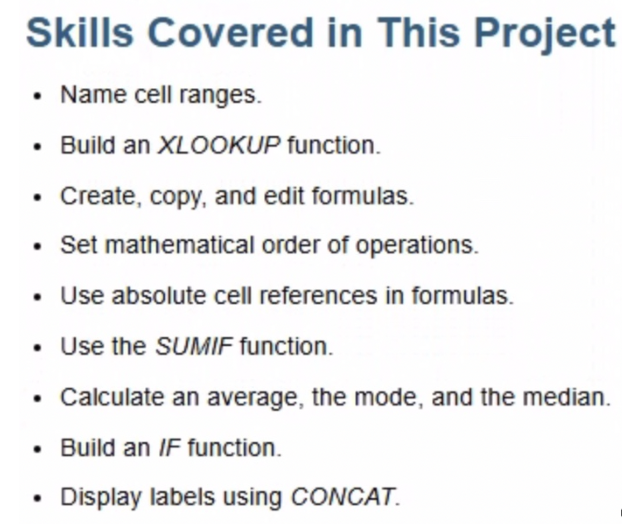

**ORIGINAL WORK_SHEETS**

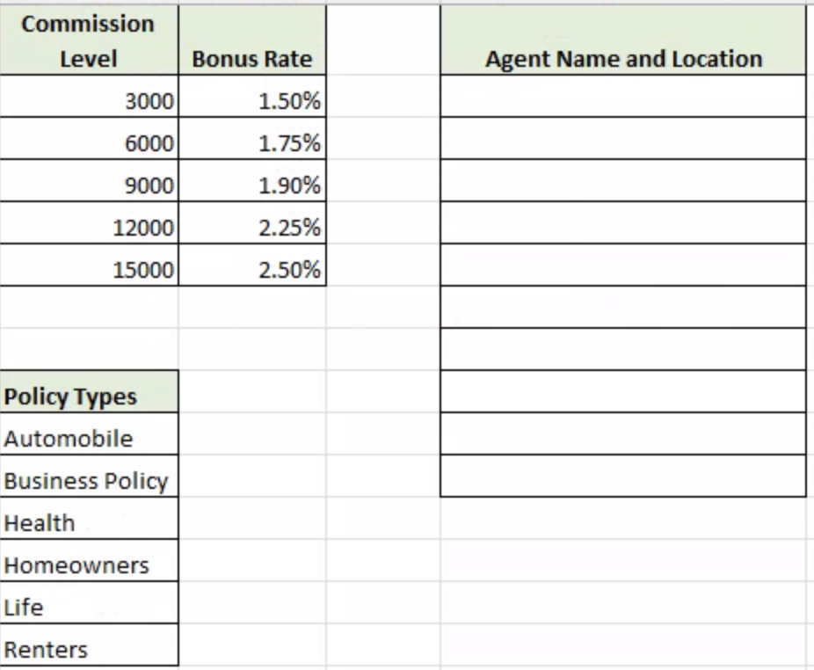

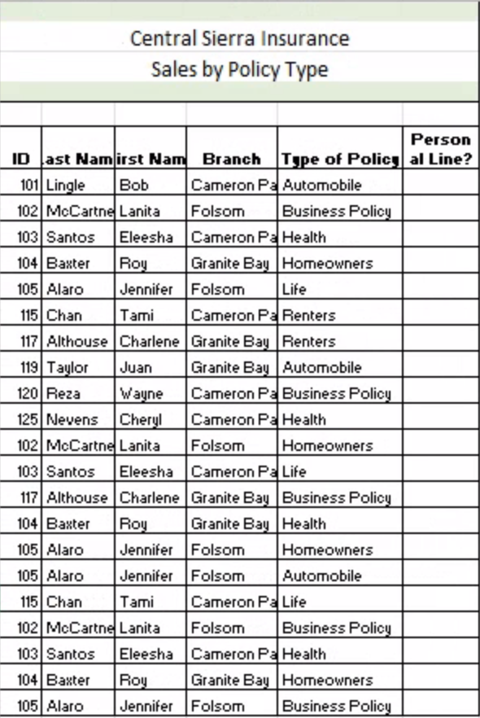

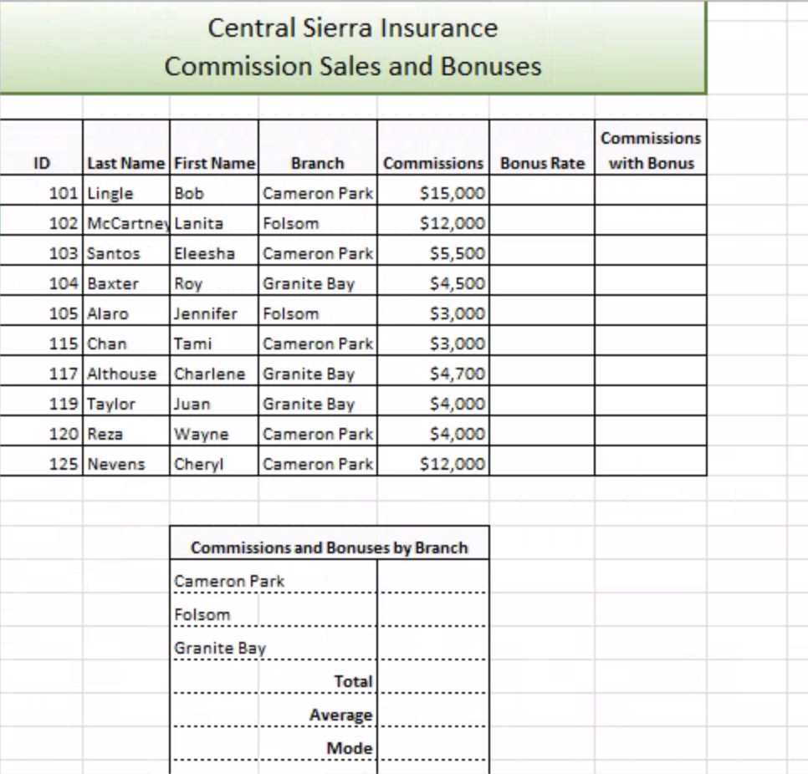

**VLOOKUP**

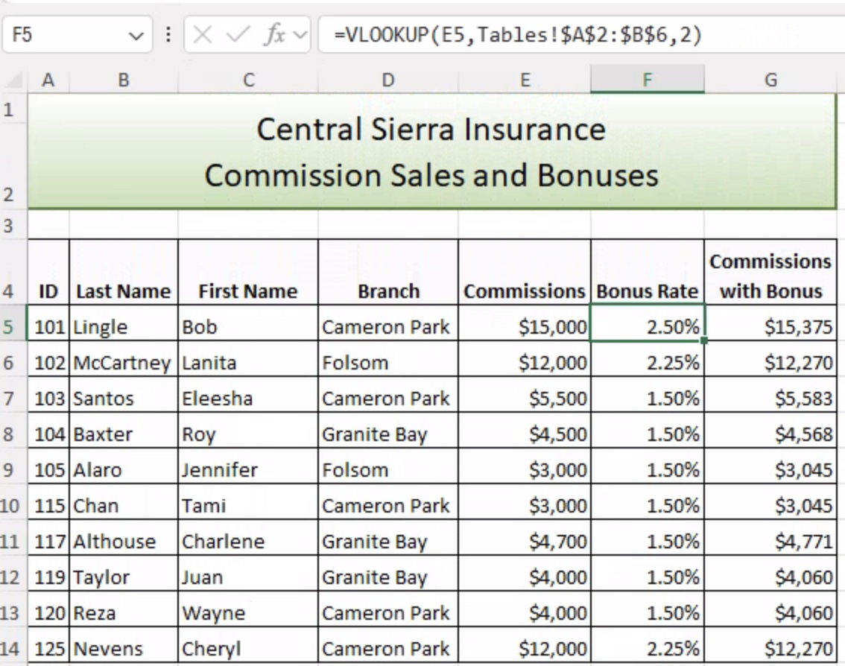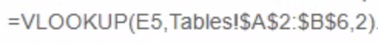

# ***# After Running a VLOOKUP and using cell E5 as the look up I was able to get 2.5% and spread that formula through cell F14. In the commissions bonus column using a multiplication equation I did commissions * bonus rate.***

**SUM IF & IF**

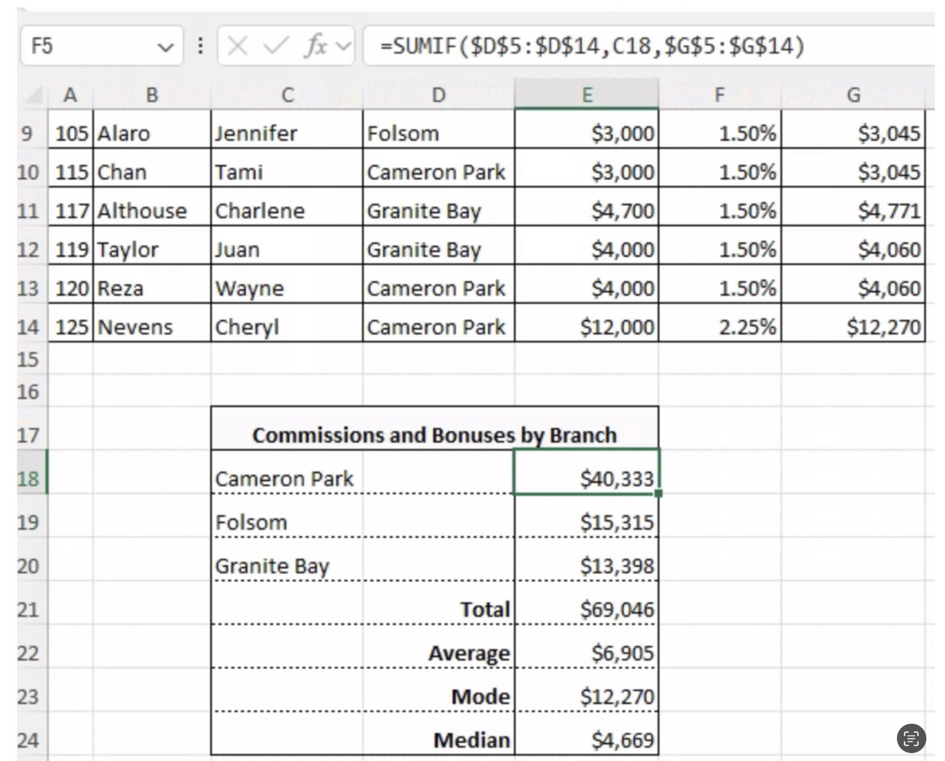

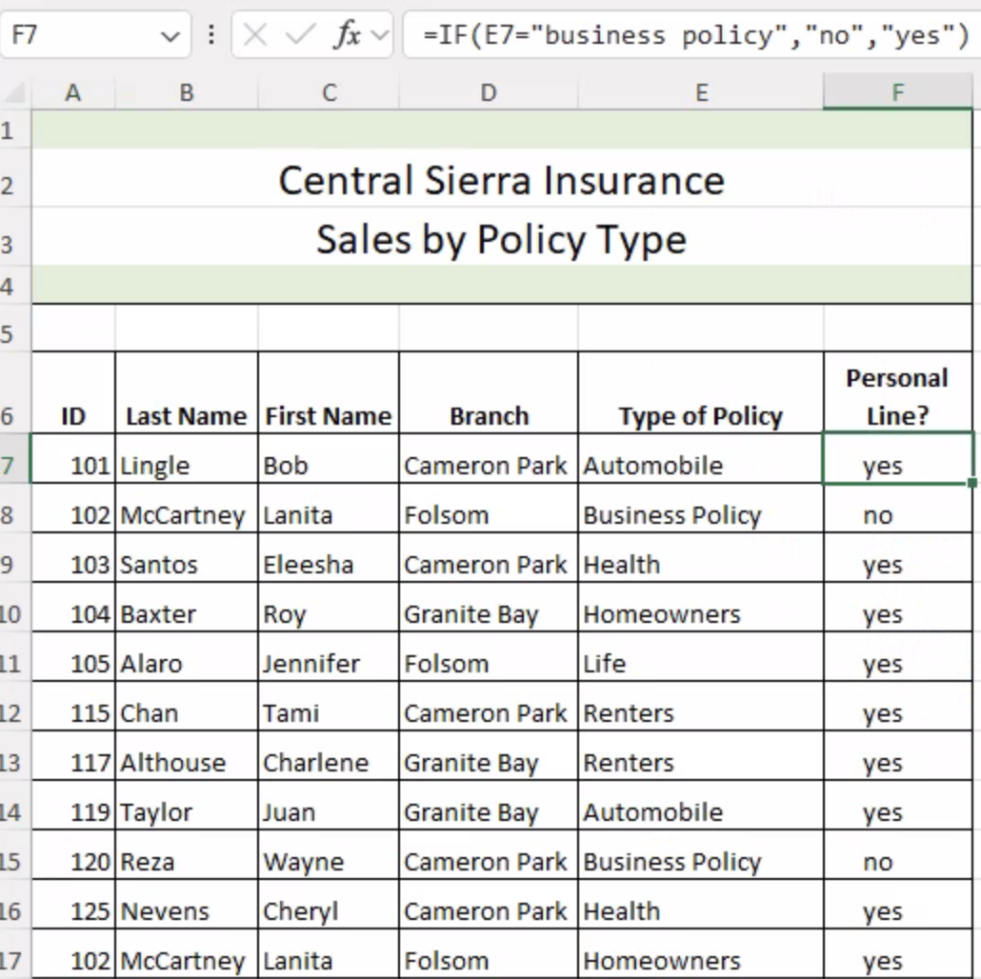

**CONCAT**

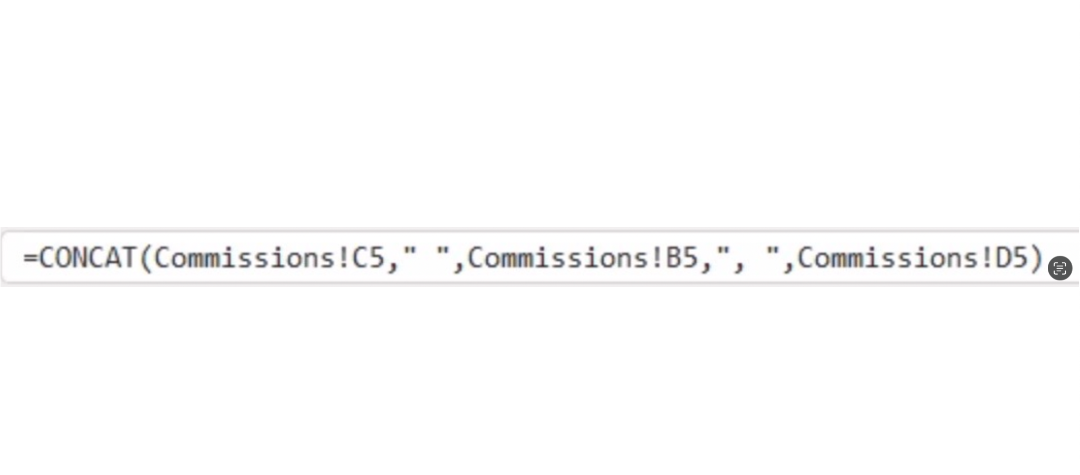

**AGGREGATE FUNC**

